|  |
| --- |
|  |
| 新概念 3 册 |
| Lesson52 |

Lesson 52 Mud is mud



**tint [tɪnt]**

**v. 染色，微染**

tint v. to slightly change the colour of something 染色，微染

She's had her eyelashes tinted.

Despite the fact that the bottle is tinted a delicate shade of green, … dye v. colour sth., esp by dipping in a liquid 染色，浸染

dye one's hair

dye a white dress blue

Its wool, which had been dyed black, had been washed clean by the rain!

stain v. colour (wood, fabric, etc) with a substance that penetrates the material 染色，渍染，着色

He stained the wood dark brown. We've decided to stain the shelves blue.

colour v. put colour on (sth.), e.g. by painting, dyeing or staining 着色

colour a picture colour a wall green **dispel [dɪ'spel]**

v. 驱散，打消

dispel v. to make sth. go away, esp. a belief, idea, or feeling 驱散，打消

dispel doubts / fears / worries / rumors / hesitations / prejudice … This brief experiment would dispel any further doubts you might have.

Reading about them increases our understanding without dispelling our fears. “pel” = push

dispel propel

repel expel

compel impel

be / feel compelled to do be / feel impelled to do **outlandish [aʊt'lændɪʃ]**

adj. 稀奇古怪的，非常怪异的

outlandish = bizarre adj. extremely strange and unusual 稀奇古怪的，非常怪异的

an outlandish hairstyle

dancers in rather bizarre costumes strange unusual odd peculiar

At the time, this did not strike me as odd.

These peculiar forms not only seemed designed to shock people emotionally, but to give them electric shocks as well!

weird

A really weird thing happened last night. eccentric

His eccentric behaviour lost him his job.

True eccentrics never deliberately set out to draw attention to themselves.

outrageous [aʊt'reɪdʒəs]

**adj. 令人震惊的，极其不合理的； 非常奇怪的**

outrageous adj. 1. very shocking or unreasonable 令人震惊的，极其不合理的

His treatment of his wife is outrageous.

She blames me for causing her father's death. But that's outrageous!

Gesticulating wildly, the man acted as if he found my offer outrageous, but he eventually reduced the price to £10.

outrageous adj. 2. extremely unusual and slightly amusing or shocking 非常奇怪的

outrageous clothes / behaviour

She says the most outrageous things sometimes.

Harry used to consider it a great joke to go into expensive cosmetic shops and make outrageous requests for goods that do not exist.

freckle ['frekl]

**n. 雀斑**

freckle n. one of the small light-brown spots on the human skin 雀斑

Ann's face and back are covered with freckles.

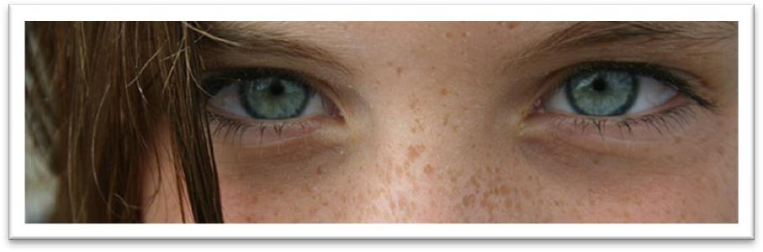

mole n. small permanent dark spot on the human skin 痣

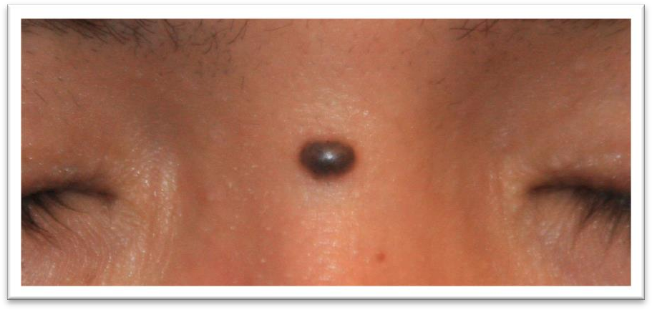

beauty spot / beauty mark n. a small dark mark on a woman's face - used when you think it is attractive 美人痣

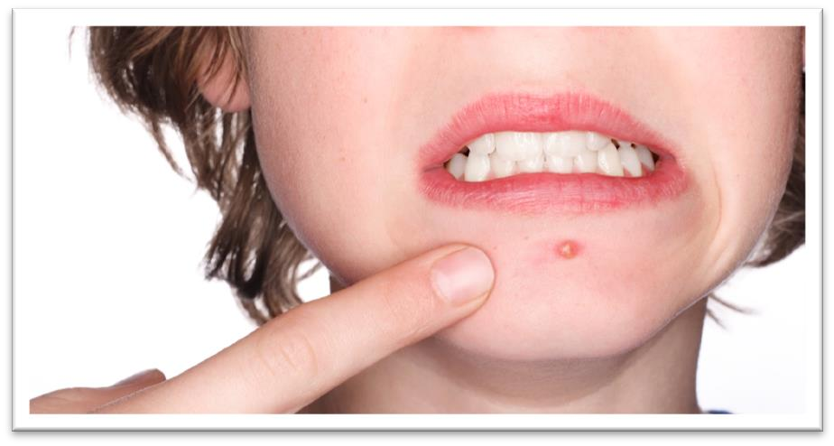acne n. 痤疮，粉刺

Many adolescents suffer from acne. dimple n. 酒窝

chin dimple

n. 下巴窝



intoxicate [ɪn'tɒksɪkeɪt]

**v. 使醉酒；使陶醉**

intoxicated adj. 1. (fml.) drunk 醉酒的

The driver was clearly intoxicated.

intoxicated adj. 2. feeling so excited or happy about something that you cannot think clearly 陶醉的

be intoxicated by / with …

He was intoxicated by / with success.

Intoxicated by his success, Harry then asked for perfumed mud. toxic noxious poisonous

toxic chemicals / substances / gases

Carbon monoxide is a colorless, odorless and noxious gas. mud is mud

call a spade a spade tell it like it is

tell somebody straight

I told her straight that she was wrong..

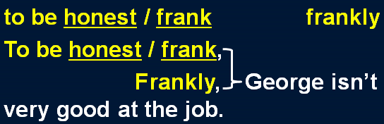

keep v. have sth. in a particular place 在某处存放或放置某物

Where do you keep the cutlery?

Always keep your driving licence in a safe place. George kept a bottle of whiskey under his bed.

oddly shaped forms

curiously shaped bits of metal She has a perfectly shaped figure.

heart-shaped pear-shaped V-shaped on display = on show 展示，陈列

A collection of photographs was on display in the hall.

Even people who take no interest in art cannot have failed to notice examples of modern sculpture on display in public places.

My cousin, Harry, keeps a large curiously shaped bottle on *permanent* display in his study. Her work is on *temporary* display at the gallery.

The locomotive is kept on *static* display in the National Railway Museum.

造句：乔治在书房里一直陈列着一枚金牌。

George keeps a gold medal on permanent display in his study.

Despite the fact that the bottle is tinted a delicate shade of green, an observant visitor would soon notice *that it is filled with what looks like a thick greyish substance*.

despite the fact that ... (fml.)

in spite of the fact that ... (fml.)

= tough / although / even though / while ...

介词 + 名词 + 同位语从句

= 普通从属连词

for the reason that … (fml.) because of the fact that … (fml.) due to the fact that … (fml.)

on account of the fact that … (fml.)

= because …

delicate / light adj. 颜色淡的，浅色的dark / deep adj. 颜色浓的，深色的bright adj. 颜色亮的，鲜艳的

shade n. a particular type of red, green, blue etc. 色度

shade of …

a delicate shade of green a bright shade of pink

a deep shade of blue

observant adj. perceptive; eagle-eyed 善于观察的，敏锐的

powers of observation 观察力

greyish (BrE) / grayish (AmE) adj. slightly grey 浅灰色的，灰了吧唧的

yellowish reddish bluish

greenish blackish whitish …

If you *were to* ask Harry what was in the bottle, he *would* tell you *that it contained perfumed mud*.

If + S.+ should do, S.+ would / should / could / might + do

If + S.+ did / were to do, S.+ would / should / could / might + do

If you *were to ask* Harry what was in the bottle, he *would* tell you that it contained perfumed

mud.

If you *expressed* doubt or surprise, he *would* immediately invite you to smell it and then to rub some into your skin.

*Were* you *to ask* Harry what was in the bottle, he *would* tell you that it contained perfumed mud. perfumed adj. pleasant to smell because perfume has been added or used 加香水的，有香味的perfumed soap / candles

If you *expressed* doubt or surprise, he *would* immediately invite you *to smell it* and then *to rub some into your skin*.

rub sth. with sth.

She began rubbing her hair with a towel.

A crowd of people gathered round him and a lady rubbed his arm with soap and butter, but George was firmly stuck.

rub sth. into sth.

rub salt into the wound

Rub the cream well into your skin.

dispel doubts / fears / worries / rumors / prejudice *…*

How Harry came into the possession of this outlandish stuff makes an interesting story *which he is fond of relating*.

came into (the) possession of sth. = get sth.

On her father's death, she came into possession of a vast fortune.

How did the painting come into your possession (= how did you get the painting)? stuff n. [U] (infml.) things 东西，玩意儿

I've got some sticky stuff on my shoe. Do you call this stuff beer?

be fond of …: having a great liking for … 非常喜欢…… I've always been very fond of you.

John's extremely fond of pointing out other people's mistakes. relate sth. (to sb.)（向某人）讲述某事

We know instinctively, just as beekeepers with their bees, that misfortune might overtake us if the important events of our lives were not related to it.

History does not relate whether his friend accepted his medical help, but in all probability he did. *Furthermore*, the acquisition of this bottle cured him of a bad habit he had been developing for years.

furthermore further what is more / what’s more moreover besides

in addition additionally the acquisition of language

The money will be spent on acquisitions for the university library. cure sb. cure a disease

cure sb. of a disease

heal sb. heal sb. of a disease heal a disease X

There is no cure for AIDS.

develop / catch / acquire / form / cultivate / foster a habit change / alter a habit

correct a habit

abandon / give up / drop / discard / kick a habit

Harry used to consider it a great joke *to go into expensive cosmetic shops and make outrageous requests for goods that do not exist*.

The expensive shops in a famous arcade near Piccadilly were just opening.

cosmetics n. [pl.] 化妆品

Lipstick and hair conditioner are cosmetics.

make-up / makeup n. [U] 化妆品

girls in heavy make-up She doesn't wear makeup. cosmetics

cosmic cosmos comic comet

make a … request for …

make repeated requests for help

They have made an urgent request for international aid. issue / make a … appeal for …

The police have issued a new appeal for information.

The girl's family have made a public appeal for help to try and catch her killer.

would 和 used to do 类似，都可以表示过去习惯性的动作，如：One day in a week he would spend a whole day in silence. 但注意：would 不能用在故事开头，往往在故事开头用 used to do，而后面换为 would do，如：We used to work in the same office and we would often have coffee together.

Harry used to consider it a great joke to go into expensive cosmetic shops and make outrageous requests for goods that do not exist. He would invent fanciful names on the spot. On entering a shop, he would ask for a new perfume called 'Scented Shadow' or for 'insoluble bath cubes'. If a shop assistant told him she had not heard of it, he would pretend to be considerably put out. He loved to be told that one of his imaginary products was temporarily out of stock and he would faithfully promise to call again at some future date, but of course he never did.

We are less credulous than we used to be. In the 19th century, a novelist would bring his story to a conclusion by presenting his readers with a series of coincidences ― most of them wildly improbable.

do sth. on the spot

= do sth. immediately

He had to make a decision on the spot.

On entering a shop, he would ask *for a new perfume called 'Scented Shadow'* or *for 'insoluble bath cubes'*.

on prep. as soon as 刚一

What was your reaction on seeing him?

The curtain went up on the final act of the play and revealed the aristocrat sitting alone behind bars in his dark cell.

in prep. during the act or process of 在……过程中

He tripped in racing for the bus.

In the last act, a gaoler would always come on to the stage with a letter which he would hand to the prisoner.

In seeking independence, they do not sacrifice their human dignity. insoluble adj. cannot be dissolved; not soluble 不能溶解的

If a shop assistant told him she had not heard of it, he would pretend to be considerably put out. put out adj. [Br.E.] [never before noun] annoyed 气愤的，不悦的

He seemed a bit put out at not having been invited.

He loved to be told that one of his imaginary products was temporarily out of stock and he would faithfully promise to call again at some future date, but of course he never did.

imaginary adj. 虚构的

imaginative adj. 富于想象力的

She is a very student. She’s always talking about travelling to outer space.

(A) imaginary (B) imaginative

(C) imaginable (D) imagining temporarily adv. 暂时，临时permanently adv. 长期，永久

in / out of stock（商店中）有/无现货的Have you any grey pullovers in stock?

I'm sorry, that swimsuit is temporarily out of stock in your size. faithfully adv. 忠诚地，诚恳地

He had served the family faithfully for 40 years. Ann faithfully promised never to tell my secret.

call v. [Br.E.] to stop at a house or other place for a short time to see sb. or do sth. 在某处短暂停留以拜访某人或做某事

She called for a chat. call in at sth.

Will you call in at the supermarket for some eggs and milk?

After crossing the equator, the captain called in at a port to have a new rudder fitted, but by now the Thermopylae was over 500 miles ahead.

at a … date: a time in the past or future 在过去或未来的某时

The exact details of the plan will be worked out at a later date. Johnson had agreed at an earlier date to take on the role of chairman.

The election is scheduled to take place at an unspecified date in the autumn.

How Harry managed to keep a straight face during these performances is quite beyond me. keep a straight face: stop oneself from smiling and laughing 板着脸，忍住不笑

Brian looked ridiculous in leather trousers, and I was desperately trying to keep a straight face. straight-faced adj. 板着脸的

We laughed, but Chris was straight-faced and seemed a little offended by the joke.

be beyond sb. to be too difficult for someone to understand 无法理解

Why people are prepared to tolerate a four-hour journey each day for the dubious privilege of living in the country is beyond me.

be quite / completely beyond sb.

It's quite beyond me why anyone would want to marry him.

The system was complicated and completely beyond the learners.

prompt v. to encourage sb. to speak by asking them questions or suggesting words that they could say 提问或提示以鼓励某人说

'And then what happened?' he prompted.

The speaker was hesitant and had to be prompted occasionally by the chairman.

exclusive adj. very expensive, and therefore available only to wealthy people 高级的，高档的

an exclusive store / restaurant / neighborhood

Newspapers and magazines offered the family huge sums for the exclusive rights to publish stories and photographs.

The shop assistant looked puzzled and Harry repeated the word, slowly stressing each syllable. stress v. to pronounce a word or part of a word so that it sounds louder or more forceful 重读The word 'machine' is stressed on the second syllable.

When the woman shook her head in bewilderment, Harry went on to explain *that ‘Myrolite’ was a hard, amber-like substance which could be used to remove freckles*.

in bewilderment = in confusion = in puzzlement = in perplexity She looked at him in bewilderment.

Matt stared at her in confusion. She frowned in puzzlement.

Jane looked about in perplexity.

convey sth. to sb. 向某人传达或表达…… Please convey my good wishes to your parents.

If you see James, do convey my apologies to him.

The poem perfectly conveys to the reader the poet’s feelings.

This explanation evidently conveyed something to the woman and she searched shelf after shelf. This explanation evidently conveyed something to the woman who searched shelf after shelf.

But when the train dawdled at *station* after *station*, I began to wonder. sth. after sth.

*day* after *day week* after *week year* after *year time* after *time*

He fired *shot* after *shot*.

Shelley sent him *letter* after *letter* to explain the delay. They sent *regiment* after *regiment* to attack us.

In *factory* after *factory* we were shown machines built by the workers themselves.

produce v. if you produce an object, you bring it out or present it, so that people can see or consider it 出示，拿出

Produce your ticket!

They made no effort to hide their amusement whenever I produced a packet of sweets from my pocket.

all sorts / kinds / types of sth. sth. of all sorts / kinds / types 各种各样的，各式各样的……

all sorts of silly jokes

all sorts of weird concoctions all sorts of indignities vehicles of all kinds

concoction n. sth. that has been made out of several things mixed together 调制品，混合物

a concoction of honey, yogurt, oats, and apples

comply with / fulfill / meet (with) / satisfy / suit *one’s requirements* The new computer system will meet (with) *all our requirements*. put on an act 装模作样

He wasn’t really angry; he just put on an act. put on sth. 假装

put on a smile put on airs

put on an injured expression

Intoxicated by his success, Harry then asked for perfumed mud. blank adj. showing no feeling, understanding or interest 茫然的Steve looked blank and said he had no idea what I was talking about. blank astonishment （惊讶得）目瞪口呆

a look of blank astonishment

However, it was his turn to be surprised, for the woman's eyes immediately lit up and she fetched several bottles *which she placed on the counter for Harry to inspect*.

it is one’s turn (to do sth.) It's your turn.

It's our turn to drive the kids to school this week.

light up if someone’s face or eyes light up, they show pleasure, excitement etc.（因喜悦、兴奋等脸上或眼中）露出光彩

His eyes lit up with laughter. Her face lit up with pleasure.

Suddenly, I saw the Officer's face light up.

… she fetched several bottles and she placed them on the counter for Harry to inspect.

… she fetched several bottles which she placed on the counter for Harry to inspect.

(just) for once used to say that sth. unusual happens, especially when you wish it would happen more often 这一回，这一次

Be honest for once.

Just for once, let me make my own decision. For once Colin was speechless.

accept / admit / concede defeat

She is very determined, and will never admit defeat. The prime minister conceded defeat and resigned.

discreet adj. careful not to cause embarrassment or attract too much attention, especially by keeping something secret 言行小心谨慎的

The family made discreet enquiries about his background.

They are very good assistants, very discreet — they wouldn't go shouting to the press about anything they discovered while working for you.

He was glad to get away with a mere 20 pounds and he beat a hasty retreat, clutching the precious bottle under his arm.

a mere … 仅仅……

a mere 后跟单数名词时 = only a / an

在其他情况下 a mere = only

beat a (hasty) retreat leave a place quickly in order to avoid an embarrassing or dangerous situation 赶紧走了

The cat beat a hasty retreat when it saw the dog was coming. I saw my aunt coming and beat a hasty retreat.

clutch v. to hold something tightly because you do not want to lose it 紧紧抓住

She was clutching a bottle of champagne.

From then on, Harry decided that this little game *he had invented* might prove to be expensive. from then on 从那以后

from now on 从今往后

decide 不一定译为“决定”，而常常译为“（在考虑之后）确定，断定，认为”，尤其是其后加 that 引导的宾语从句时。

The pie committee decided that the best way to transport the dish would be by canal, so they insured it for the trip.

I decided that I must have taken a wrong turning somewhere.

Her first impulse was to go round all the rooms looking for the thieves, but then she decided that at her age it might be more prudent to have someone with her, so she went to fetch the porter from his basement.

The curious bottle which now adorns the bookcase in his study was his first and last purchase of rare cosmetics.

adorn v. (fml.) to decorate sth. 装饰

The walls were adorned with paintings.